**Issue Brief: BenchMarking the Results of ACM and IMPAQ Paid Leave Microsimulation Models**

This brief compares a new paid leave microsimulation model funded by the US Department of Labor (DOL) to an older version of the model. Both models are also compared to actual historical paid leave program statistics. The purpose of this exercise is to benchmark the newer model’s performance at modeling state paid leave programs, and demonstrate to users of the model the consistency of the model results with both the older model and real world data. We demonstrate that by and large the model produces estimates consistent with both the original model and real-world benchmarks.

# 1. Project Overview

Access to and use of paid and unpaid leave are critical to an individual’s financial security and quality of life (Winston, 2017). The United States remains an outlier when it comes to paid leave. Nearly every other developed country provides paid maternity leave, and most advanced industrial countries offer extended paid medical and parental leaves. In the US, there is no federal requirement for paid leave or sick days, which leaves many individuals, especially low-income workers, facing difficult tradeoffs. In 2016, only 14 percent of all US workers have access to paid family leave through their employers, and 68 percent have paid sick leave (Bureau of Labor Statistics, 2016).

However, in recent years, paid family and medical leave programs have received considerable support from both sides of the political aisle. Some states and municipalities have moved forward on paid family leave. California enacted paid family leave legislation in 2002, New Jersey in 2008, Rhode Island in 2013, New York in 2016 (effective January 2018), District of Columbia in 2017 (effective July 2020), and Washington in 2017 (effective January 2020). Several states and municipalities using government funds have examined the feasibility of instituting paid leave polices in their constituency. However, the sophistication and reliability of these methods are inconsistent. In order to support different state’s quantitative evaluation of proposed paid leave policy, DOL funded the development of a microsimulation model built by Randy Albelda and Alan Clayton-Matthews (the ACM model) in partnership with the Institute for Women’s Policy Research (IWPR). This model offered a rigorous way for any state or municipality to test different scenarios of paid-leave programs and to estimate the implications on costs in benefits paid out.

The ACM model was built in proprietary programming languages and requires advanced programming skills to understand and use. To make the model more accessible to a wider audience, DOL contracted with IMPAQ International and IWPR to create a new version of the model (for referential convenience, we will use the term “the IMPAQ model” in the remainder of the brief). The underlying purpose of this model was similar; to still be a rigorous model of leave taking behavior that policymakers could use to quantitatively evaluate proposed leave policy. However, the IMPAQ model is built in open-source programming languages, makes several changes to the model output structure, and has an accessible graphic user interface. These changes make the IMPAQ model more accessible, customizable, and usable to a broader audience.

This brief provides a benchmark comparison between the two models against real-world leave program statistics to demonstrate the reliability of both the original and new versions at modeling real-world leave taking. The IMPAQ model is not a pure replication of the ACM model. While similar in many ways, the IMPAQ development team has made several changes for ease of use and generalizability of the model. While the intent is to keep model output estimates close to both ACM model estimates and empirically observed leave taking data, these adjustments have slight impacts on program estimates. By conducting these comparisons, we show the extent to which the ACM and IMPAQ model estimates differ. We also compare how both models compare to real-world program statistics. We then discuss the differences in results and how differences in the model structure could explain them.

We benchmark both models against actual statistics reported by three states with leave programs with appreciable historical data to observe: California, New Jersey, and Rhode Island. Corresponding with the timeframe of the 2012-2016 ACS 5-year survey data set used in the simulation models, we generally compare the 5-year averages of these states from 2012-2016. Rhode Island has only been active from 2014-2016, and so averages from only those years are used for Rhode Island.

# 2. Methodology

To compare the two models and actual statistics, we perform two different types of comparisons:

***Comparing simulated and published program costs.*** The ability to closely predict total program cost in benefit outlays has been one of the primary uses of the original ACM model; it is natural that we test the IMPAQ model’s ability to replicate these results. There are three states with sufficient historical data on benefit outlays to perform this test on: California, New Jersey, and Rhode Island. For each state, we specified the model parameters so that they can approximate the eligibility rules and benefit payout schedules as closely as possible to the actual rules of the programs. Upon completion of simulation under a given simulation method for a given state, we compute the weighted sum of benefits received by each ACS worker in that state, with weight being the population represented by the worker. This weighted sum is our simulated total program cost and is then compared against the published program outlays of the same state.

***Comparing simulated and observed population-level statistics.*** We recognize that the robustness of a microsimulation model cannot be fully verified if we can only confirm that the model can produce good estimates for the final program cost. In addition, we need to validate the model’s capability to approximate the real-world mechanisms by examining a series of key intermediate outputs. In our case, we consider the following intermediate outputs at the population level:

* Total number of workers eligible for the program
* Total number of leave takers receiving benefits
* Average lengths of leaves where takers receive benefits

All of these population level statistics can be computed directly based on the respective variables observed for each worker in the FMLA data, allowing the comparison with the simulated counterparts for model testing purpose.

Both models were run with parameters selected to mirror each state’s program rules. State program benefit and eligibility rules are drawn from a 2016 DC paid leave economic impact report (DC Council, 2016). Other than state-specific rules adjustment, default parameters were used. The selected parameters for each state are included in an appendix. Full documentation of the model and its parameters are available on request. For testing purposes, numbers generated in this memo are from the R version of the IMPAQ model.

Some of these analyses are broken out by specific leave type. Based on examination of state claims data, there are six major leave types that make up the vast majority of all states’ participants: (1) own sickness leave, (2) maternal disability, (3) new child bonding, (4) care for an ill spouse, (4) care for an ill parent, and (6) care for an ill child. In all three states, the first two leave types are paid out by the state temporary disability insurance program. The latter four types are paid out by the state paid family leave program.

# 3. IMPAQ Model versus ACM Model Results

[To be included in final draft]

# 4. IMPAQ Model versus Actual Data Results

In this section, we discuss the IMPAQ simulation results with respect to the historical data from actual programs in California, New Jersey, and Rhode Island. All model statistics are reported with the sampling standard error derived from the ACS replicate weights procedure described by the Census Bureau (Census Bureau, 2014).

## 4.1 Total Program Benefit Outlays

Exhibit 1 compares the IMPAQ model’s simulated annual benefit outlays with the actual state reported outlays averaged from 2012-2016. The actual numbers are obtained from reports published on their respective state websites.[1] For all three states, the IMPAQ model slightly underestimated total benefits outlaid by about 10%. As explored further in the next few subsections, there are a number of contributing factors for this in terms of discrepancies in estimated eligible workers, participation in the program, and length of participation. These factors vary on a state-by-state basis.

**Exhibit 1. Simulated vs. Actual Benefits Outlayed**

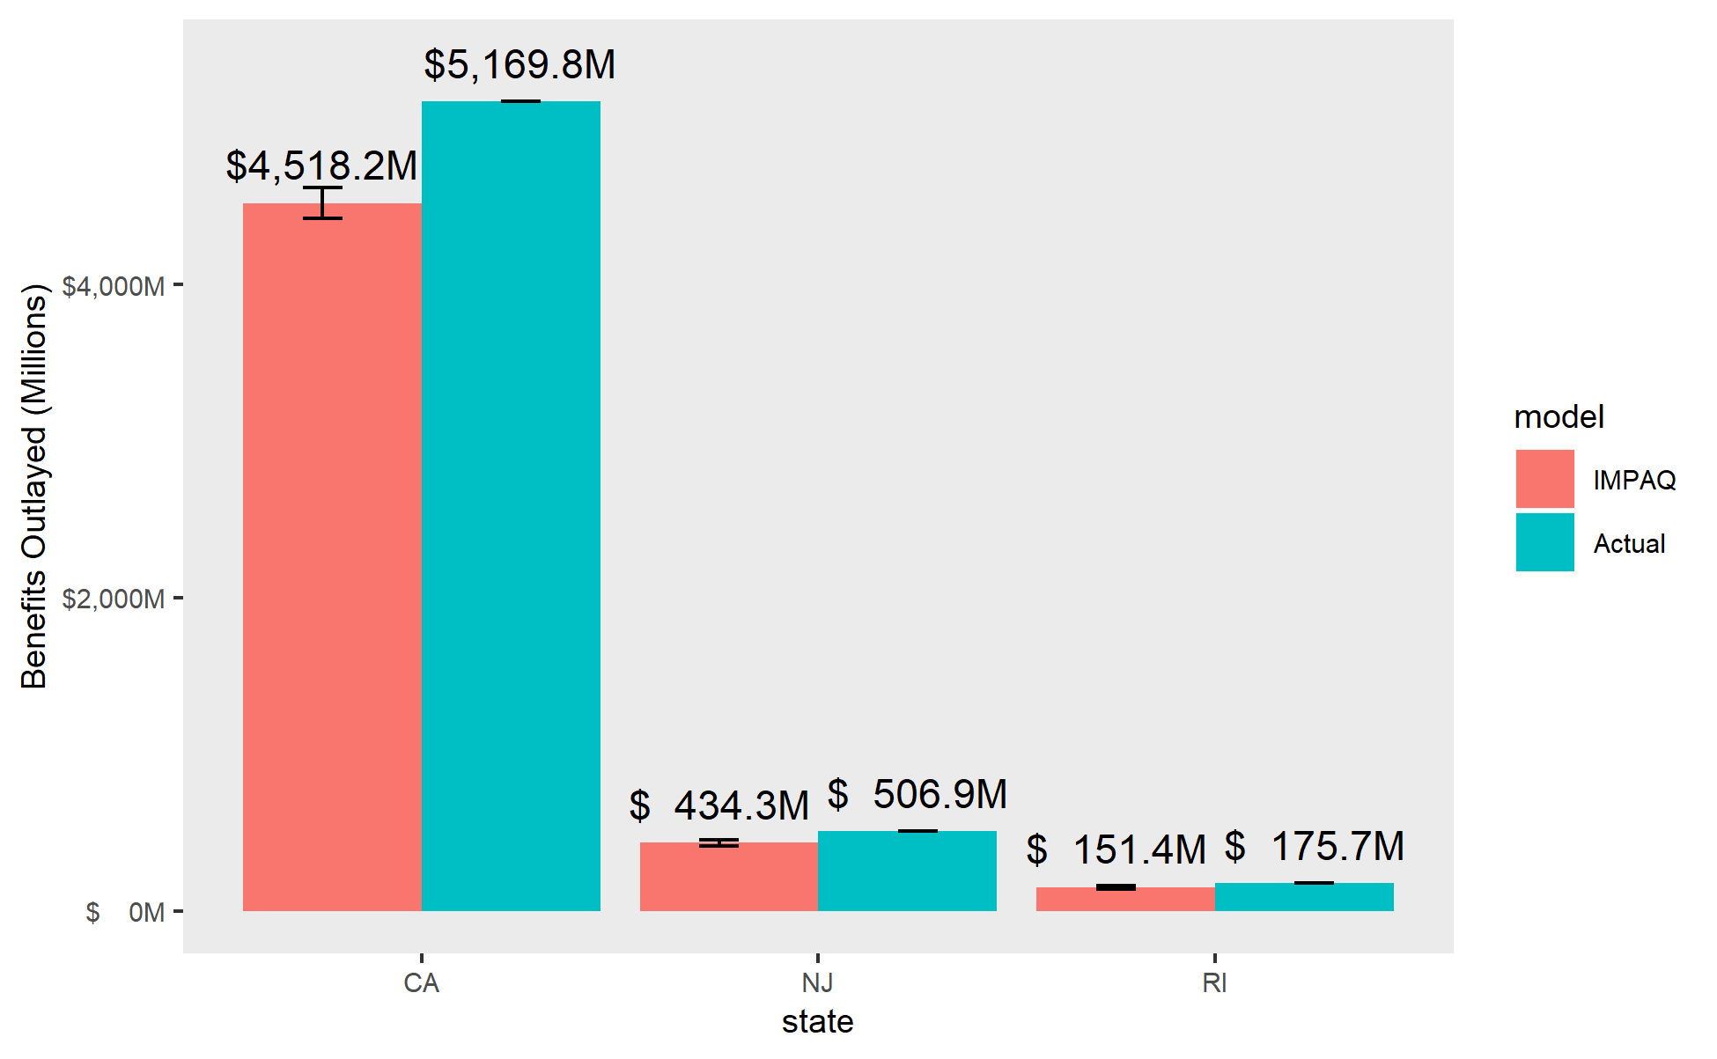

## 4.2 Total Number of Eligible Workers

Exhibit 2 compares the number of eligible workers for the program. This more aptly thought of as a benchmark comparison to ACS estimates rather than a model benchmark, as no simulation actually occurs to calculate this number. Eligibility is determined solely through original ACS variables for class of employment and earnings (the main criteria for eligibility in these three programs).

The IMPAQ model substantially underestimated the number of eligible workers in California; 12.7 million versus 17.2 million workers. The ACS indicates there are approximately 17 million individuals working in California alone. From ACS, about 3 million are excluded from eligibility due to self-employment or public employment in the government. The remaining 1.5 million are excluded due to failure to meet earnings requirements. The earnings requirements are subject to some error, as while earnings can only be observed in annual aggregate in the ACS, California’s earnings requirements are based on quarterly earnings. The discrepancy in employment eligibility will require further investigation; the actual California eligibility criteria and the reported criteria in the DC Council report are discrepant. Despite this, we see the model producing accurate program participation numbers in Exhibit 3 which partially alleviates this concern.

The model comes very close to simulating the actual number of New Jersey eligible workers. There is a nuance to eligibility in New Jersey; the displayed number is for eligibility for Medical Leave coverage (maternal disability and own illness leaves), which has a lower number of eligible workers due to an opt-out option for employers with private insurance. Eligibility for Family Leave (ill relative and child bonding) is 30% higher at 3.83 million. The eligibility differential is handled by a separate set of user-specified eligibility parameters in the model. The Rhode Island simulation also produces numbers very close to actual eligibility numbers.

**Exhibit 2. Simulated vs. Actual Eligible Workers**

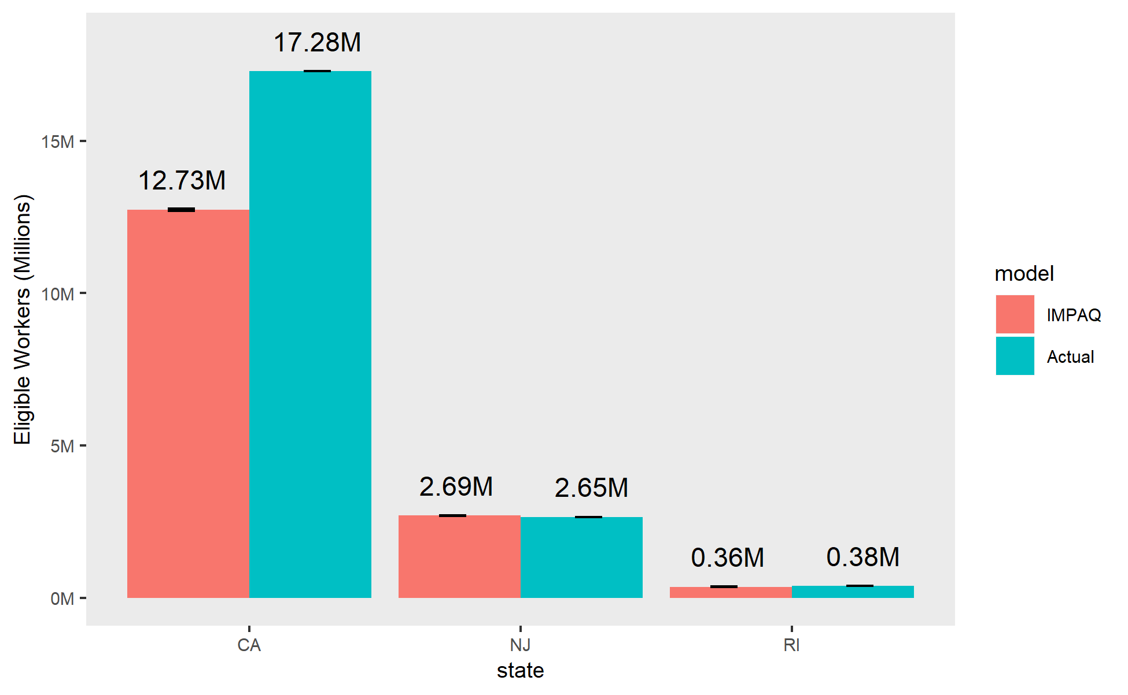

Note: Actual numbers are estimated 2015 eligible population (DC Council, 2016).

## 4.3 Total Number of Leave Takers

This section discusses the total number of individuals that actually take leave and claim benefits for each leave type. The actual numbers are derived from claims reporting found in the same state reports as the overall program benefit outlays mentioned previously.

Exhibit 3 presents the results for California for each of the six leave types. The IMPAQ model gets close to the overall number of participants (1.10 million participants simulated versus 1.01 million actual). However the distribution of leave types is different; the simulated model tends to overstate ill relative and maternal disability leave taking while understating own leave taking.

**Exhibit 3. Simulated vs. Actual Participating Leave Takers in California**

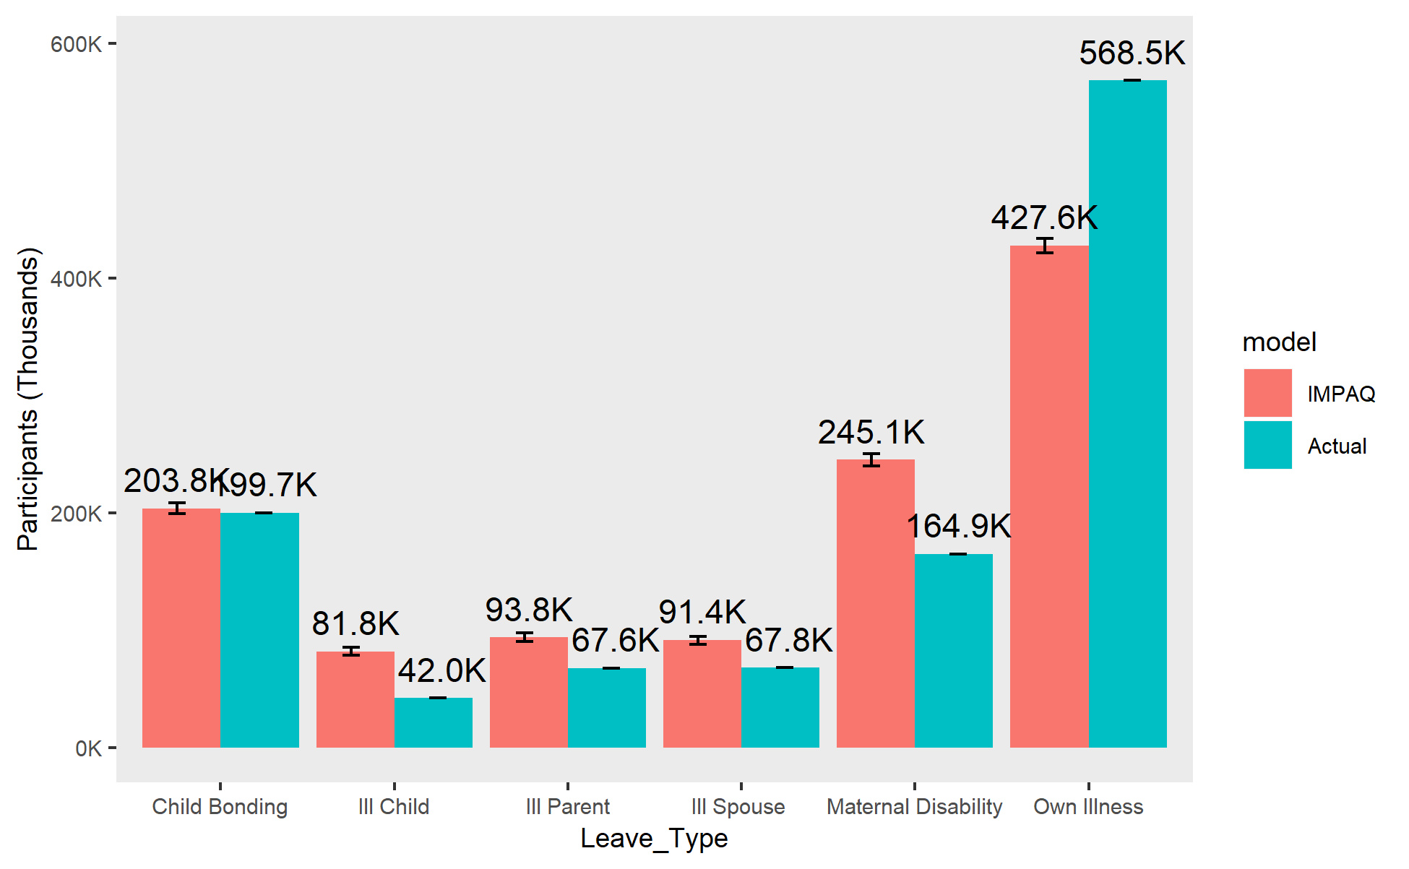

Exhibit 4 shows participant numbers in New Jersey. The model gets very close to New Jersey in both overall participation (about 125,000 participants simulated compared to 124,000 actual participants), and the distribution of leave types within the participant population.

**Exhibit 4. Simulated vs. Actual Participating Leave Takers in New Jersey**

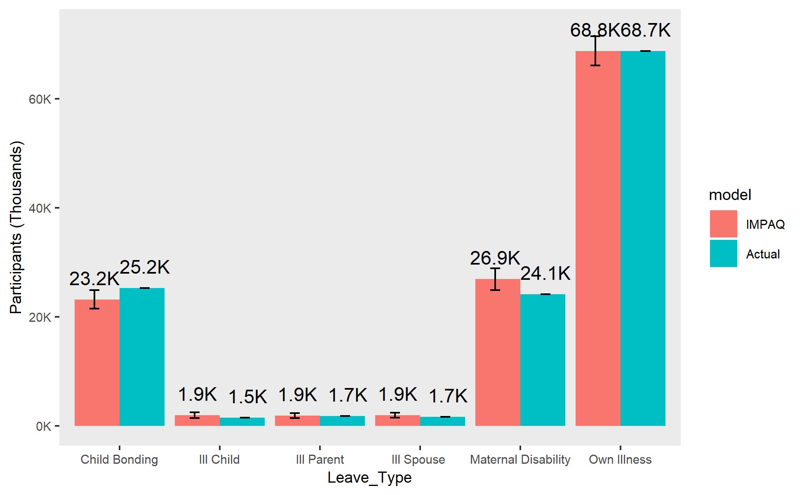

Exhibit 5 shows the participation results for Rhode Island. The model slightly understates the number of participants in the Rhode Island program; the simulation produced about 38,400 participants compared to 44,900 participants in the actual program. By leave type, the model simulated similar numbers except for own illness and child bonding leaves. The underestimations in these two leave types explain the overall difference in leave program participation. This is a likely explanation for why the model understated the overall benefit outlays for the Rhode Island program.

**Exhibit 5. Simulated vs. Actual Participating Leave Takers in Rhode Island**

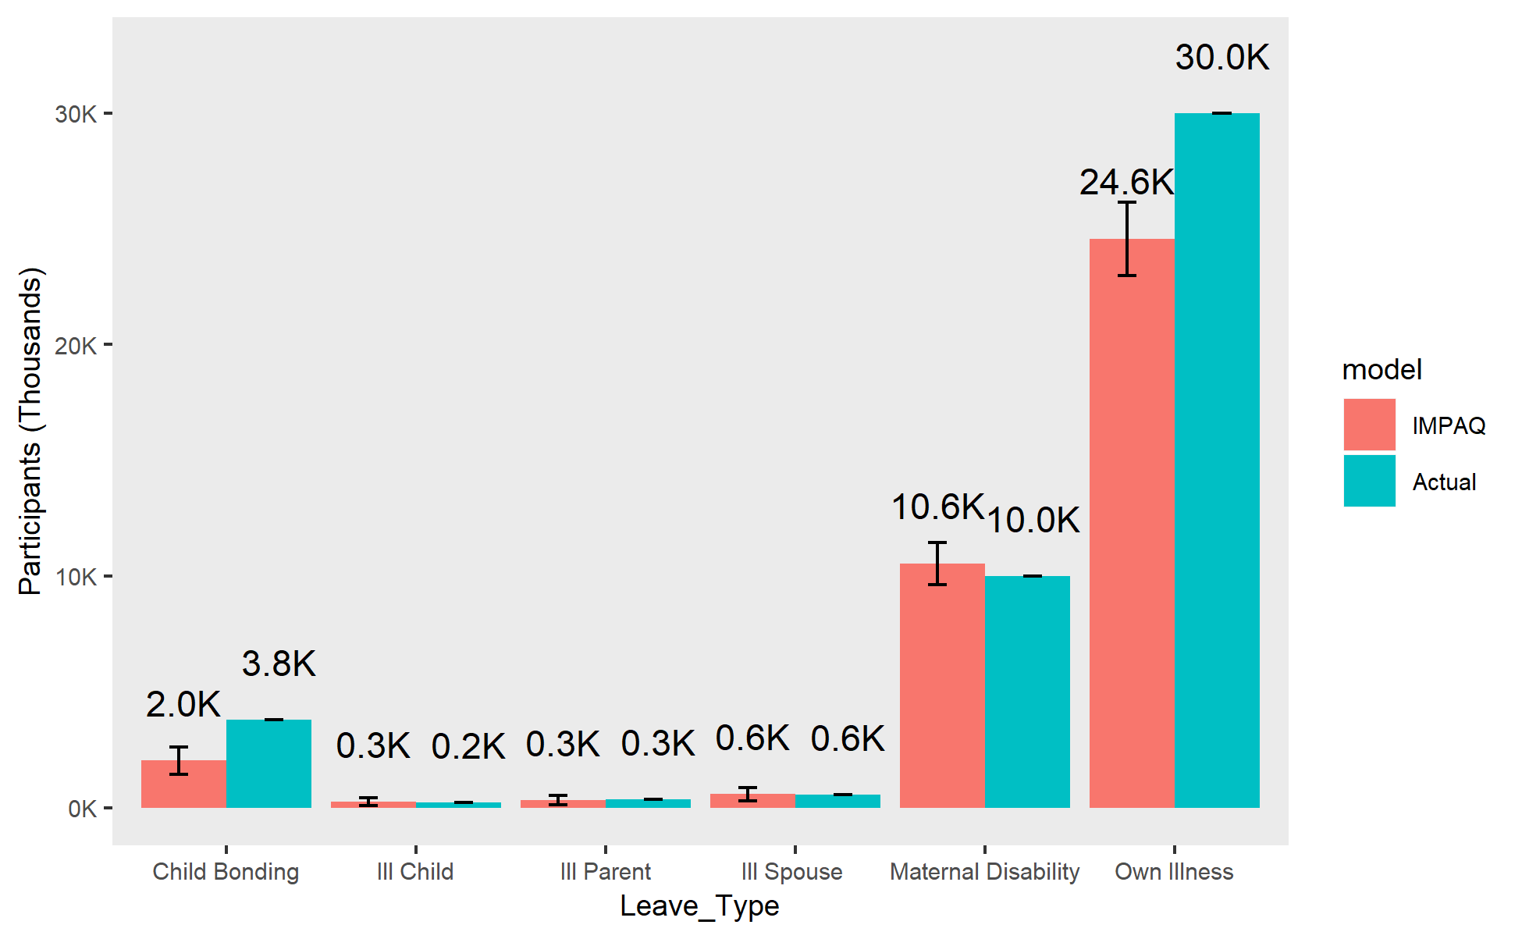

## 4.4 Average Length of Leaves

Of the three states, only New Jersey reported weeks of participation in sufficient detail to compare the model to. For New Jersey, the model simulated substantially shorter participation for all leave types. This could be one factor as to why the overall estimate of New Jersey’s program cost fell short of actual numbers despite accurately modeling the number of eligible workers and program participants.

**Exhibit 6. New Jersey Simulated vs. Actual Mean Participation Length (in Weeks)**

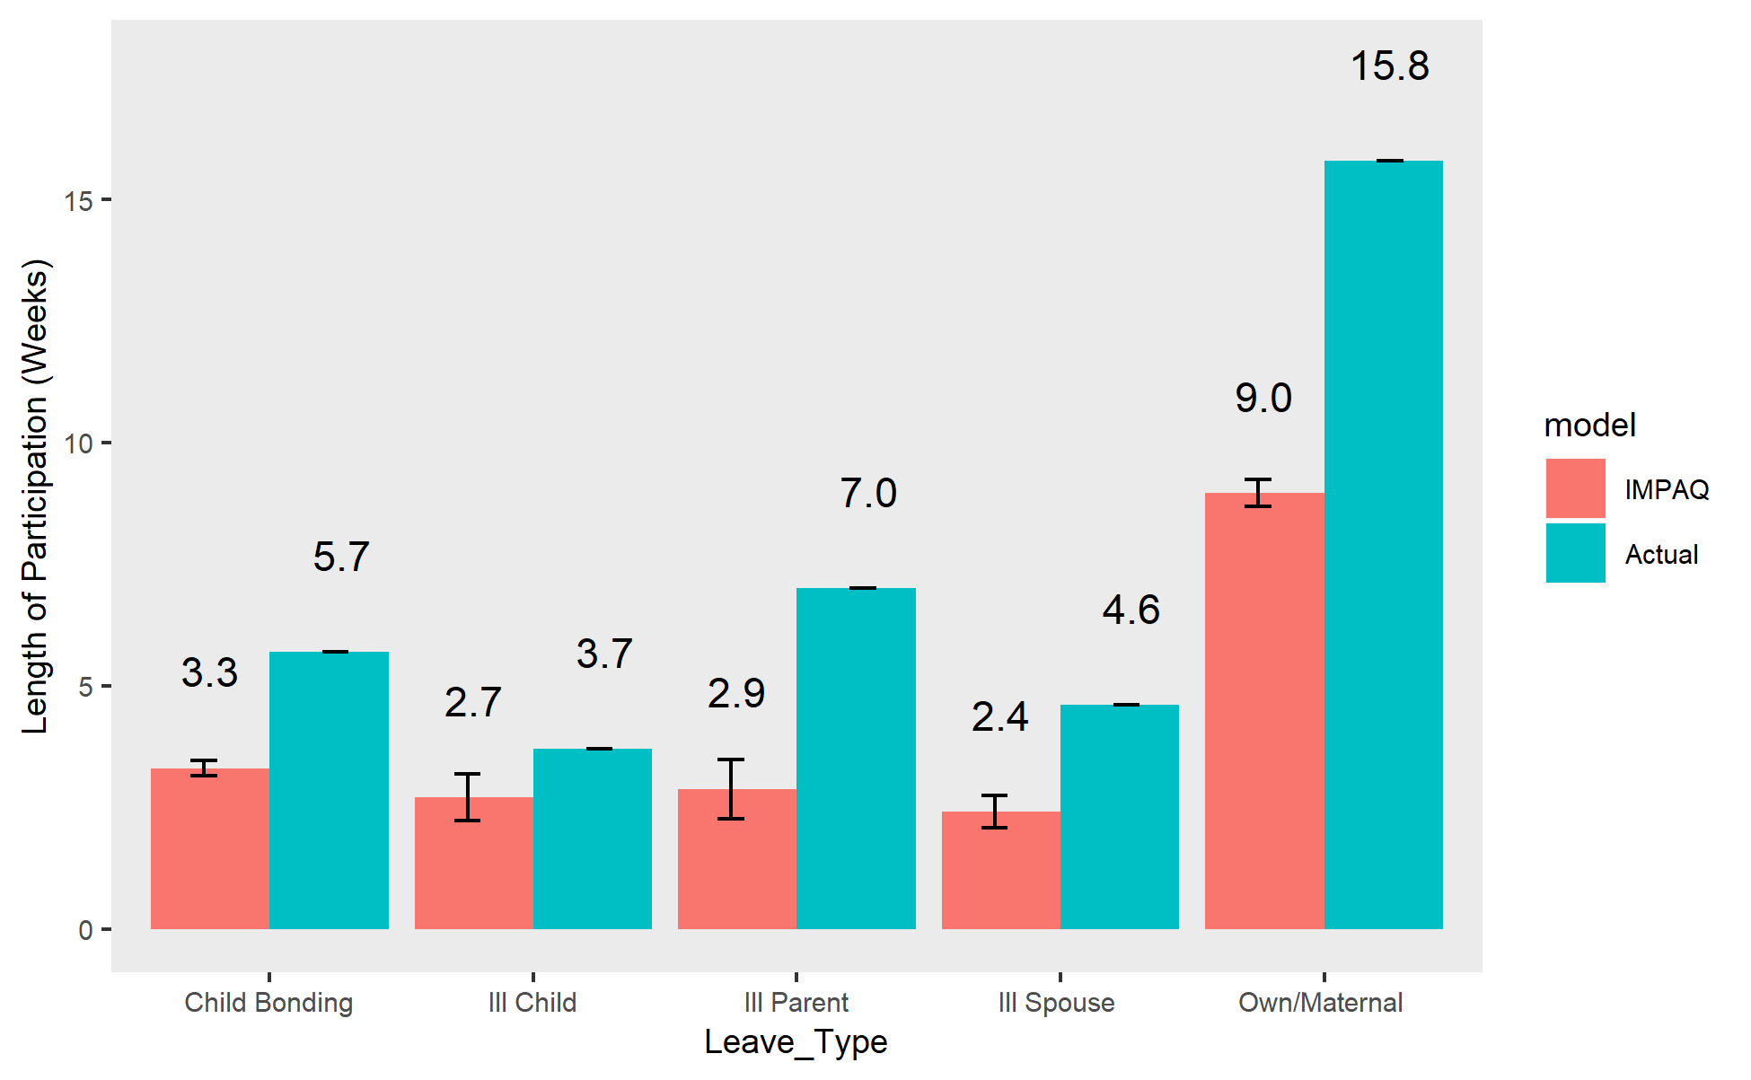

Note: Actual length of leave statistics not available for California and Rhode Island

# 5. Conclusion

Overall, the IMPAQ model performs reasonably well at replicating the real-world state leave programs and participation. However, every state’s program cost is slightly understated by the model. The possible reasons for this varied by state. California’s eligible population was underestimated by the model. In Rhode Island, the model simulated fewer child bonding and own illness leave takers than in reality. In New Jersey, the model simulated shorter participation lengths than actually observed. This suggests that the model’s estimate should be treated as a lower bound for what simulated programs might cost, and a suggested upper bound might be about 10-15% greater than the simulated cost.

The reader should note that these are not the only estimates the IMPAQ model could produce. Other parameter specifications could be altered to correct the variance in simulated and observed statistics. The default settings were selected for this issue brief to demonstrate a baseline of how the model generally follows real-world and ACM model behavior.

[Paragraph comparing ACM and IMPAQ results to be inserted in final version]

# Bibliography

Winston, P. (2017). Exploring the Relationship between Paid Family Leave and the Well-being of Low-Income Families: Lessons from California. Washington, DC: U.S. Department of Health and Human Services, Office of the Assistant Secretary for Planning and Evaluation, Office of Human Services Policy.

Bureau of Labor Statistics (2016). Table 32. Leave benefits: Access, Civilian Workers, National Compensation Survey, March 2016. Retrieved from https://www.bls.gov/ncs/ebs/benefits/2016/ownership/civilian/table32a.htm.

Census Bureau (2014). American Community Survey Design and Methodology. Chapter 12: Variance Estimation. Retrieved from <https://www2.census.gov/programs-surveys/acs/methodology/design_and_methodology/acs_design_methodology_report_2014.pdf>

# Office of the Budget Director, Council of the District of Columbia (2016). Economic and Policy Impact Statement: Universal Paid Leave Amendment Act of 2016. (B21-415). Retrieved from <http://lims.dccouncil.us/Download/34613/B21-0415-Economic-and-Policy-Impact-Statement-UPLAA3.pdf>

# Appendix

**ACM Model Parameters Used**

|  |  |  |  |
| --- | --- | --- | --- |
| **Parameter** | **CA** | **NJ** | **RI** |
| DEPENDENTALLOWANCE | 10 | 10 | 10 |
| ELIGIBILITYRULES | a_earnings=300 | a_earnings=8400 | a_earnings=3840 |
| EXTENDLEAVES | Yes | Yes | yes |
| GOVERNMENT | No | No | no |
| MAXWEEKS | OH=52, MD=52, NC=6, IC=6, IS=6, IP=6 | OH=26, MD=26, NC=6, IC=6, IS=6, IP=6 | OH=30, MD=30, NC=4, IC=4, IS=4, IP=4 |
| REPLACEMENTRATIO | 0.55 | 0.66 | 0.6 |
| STATEOFWORK | CA | NJ | RI |
| TAKEUPRATES |  |  |  |
| WAITINGPERIOD | 1 | 1 | 1 |

**IMPAQ Model Parameters Used**

| **Parameter** | **California** | **New Jersey** | **Rhode Island** |
| --- | --- | --- | --- |
| ann_hours | NULL | NULL | NULL |
| bene_effect | FALSE | FALSE | FALSE |
| bene_level | 0.55 | 0.66 | 0.6 |
| bond_uptake | .02 | .01 | .01 |
| dependent_allow | 10 | 10 | 10 |
| dual_receiver | 0 | 0 | 0 |
| Earnings | 300 | 8400 | 3840 |
| ext_base_effect | TRUE | TRUE | TRUE |
| extend_days | 0 | 0 | 0 |
| extend_prob | 0 | 0 | 0 |
| extend_prop | 0 | 0 | 0 |
| fmla_protect | FALSE | FALSE | FALSE |
| full_particip_needer | FALSE | FALSE | FALSE |
| GOVERNMENT | FALSE | FALSE | FALSE |
| illchild_uptake | .01 | .001 | .001 |
| illparent_uptake | .01 | .001 | .001 |
| illspouse_uptake | .01 | .001 | .002 |
| impute_method | logit | logit | logit |
| matdis_uptake | .02 | .01 | .2 |
| maxlen_bond | 30 | 30 | 20 |
| maxlen_DI | 260 | 130 | 150 |
| maxlen_illchild | 30 | 30 | 20 |
| maxlen_illparent | 30 | 30 | 20 |
| maxlen_illspouse | 30 | 30 | 20 |
| maxlen_matdis | 260 | 130 | 150 |
| maxlen_own | 260 | 130 | 150 |
| maxlen_PFL | 30 | 30 | 20 |
| maxlen_total | 260 | 130 | 150 |
| minsize | NULL | NULL | NULL |
| own_uptake | .04 | .03 | .08 |
| SELFEMP | FALSE | FALSE | FALSE |
| topoff_min_length | 0 | 0 | 0 |
| topoff_rate | 0 | 0 | 0 |
| waiting_period | 5 | 5 | 5 |
| week_bene_cap | 1216 | 594 | 795 |
| week_bene_cap_prop | NULL | NULL | NULL |
| week_bene_min | 50 | 0 | 89 |
| weeks | NULL | NULL | NULL |

1. California:

   |  |
   | --- |
   | <https://www.edd.ca.gov/about_edd/pdf/qsdi_DI_Program_Statistics.pdf> |
   | <https://www.edd.ca.gov/about_edd/pdf/qspfl_PFL_Program_Statistics.pdf>  New Jersey: |
   | <https://www.nj.gov/labor/forms_pdfs/tdi/FLI%20Summary%20Report%20for%202016.pdf> |
   | <https://www.nj.gov/labor/forms_pdfs/tdi/TDI%20Report%20for%202016.pdf>  Rhode Island: |
   | <http://www.dlt.ri.gov/lmi/uiadmin.htm> |

  